**PROGRAM 10.5.1:**

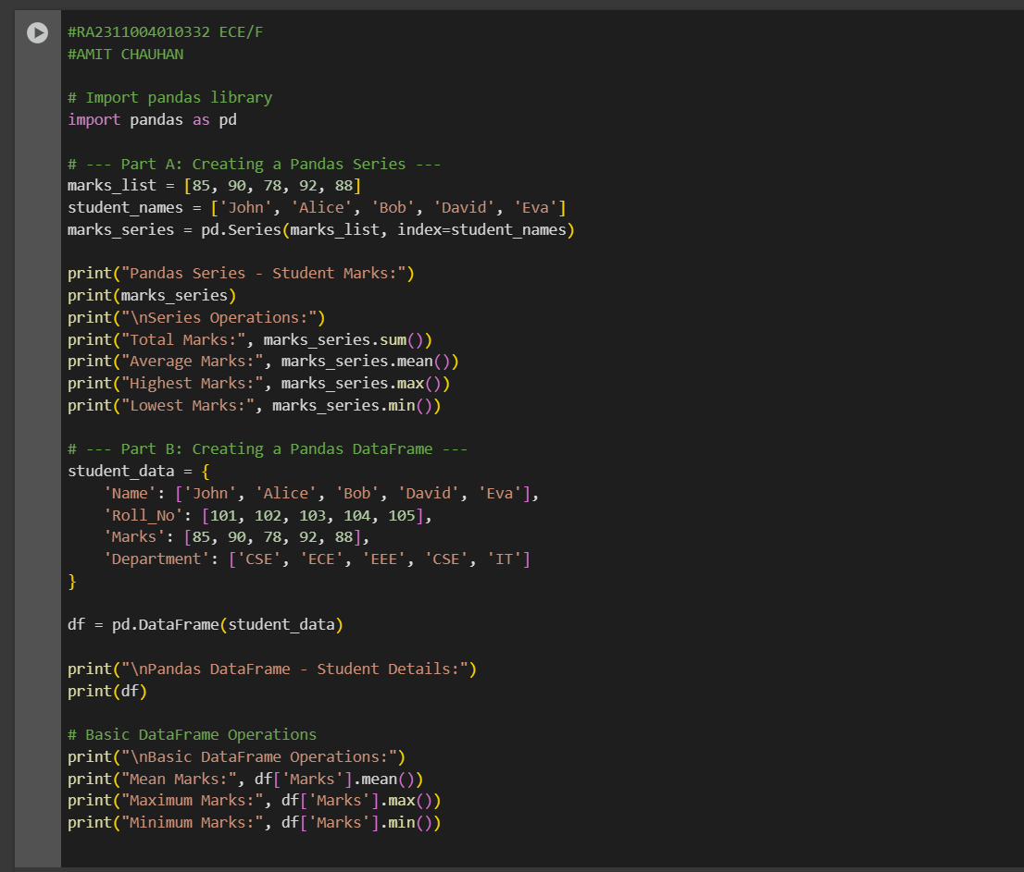

**PROGRAM 10.5.2:**

